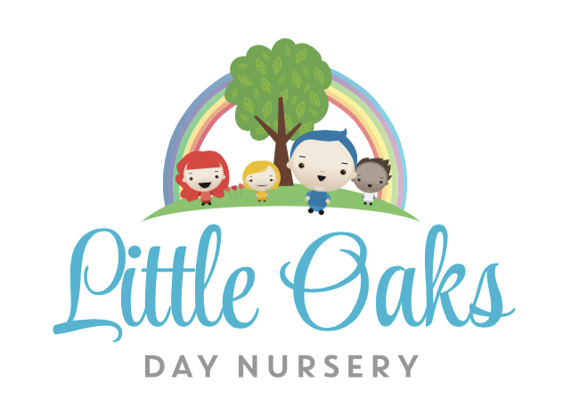



PARENT TERMS AND CONDITIONS

We believe that there needs to be a formal agreement between the Nursery and Parents / Guardian. The contract will outline the obligations and commitment, of both the Nursery and the Parent(s) / Carer(s).

This is a contract between the Owners and the Management of Little Oaks Day Nursery Penn (referred to as ‘the Nursery’) and or the Parent(s) or Legal Guardian (referred to as ‘the Parent / Guardian) of a child that is enrolled at the Nursery.

The Nursery:

1. Is operated by GLM Early Years Penn LTD.
2. Will be known as Little Oaks Day Nursery Penn and will operate from 1 Woodfield Avenue, Wolverhampton, WV4 6AG.
3. Is registered with Ofsted as a Day Care Nursery and operates within their regulations and guidelines.

The Contract:

1. The minimum contract period is for 6 months.
2. Notice Period: We require 4 weeks written notice to reduce or cancel your child’s normal booking pattern. Also if you decide not to take up a space that you have reserved then your deposit will not be returned.
3. Increasing your booking pattern is subject to availability.

HOURS OF OPERATION

Monday to Friday 7:30 – 18:00. Late collection is charged £15 for every 15 minute period. For example if you are 5 minutes late you will be charged £15. We will be closed on Statutory Bank Holidays and these days are not charged.

MONTHLY FEES

Monthly fees are at the prevailing fee schedule. The setting reserves the right to increase said fees at any times giving 1 calendar months notice of the proposed increase to parents / guardians. Monthly fees include all sick days and holiday taken as these are paid days. Fees are based on booked days not attendance. Refunds and credits are not given for days where your child does not attend due to sickness or holiday. We do not allow swapping of days unless it is permanent and there is availability. We will try to accommodate swapping of days in cases of emergency or under special circumstances.

GOVERNMENT FUNDING

Parents who qualify for funding will be entitled to claim the number of hours applicable and this will be reflected in your invoice. Funding can be stretched across the year (50 weeks). We usually apply the funding on a Monday (If your child attends on a Monday) as this ensures that no overclaim of funding is made. If an overclaim of funding is made this will be charged at our hourly rate. For funded children food will be charged or you can provide a healthy packed lunch (please ensure that no products contain nuts). We have set sessions for funded hours please speak with the Nursery Manager to discuss what sessions would best suit your needs.

PAYMENT POLICY

Parents agree that all monthly fees (full time and part time attendance) will be paid for on the first of each month in advance. Additional sessions will be invoiced on the following month unless the booked far enough in advance. Unpaid fees are subject to a £25 late payment fee if fees are not received by the 7th of the month. Unpaid fees may result in immediate suspension or termination of care unless reasonable arrangements are made and accepted by both parties.

Fees are based on booked days, not attendance, therefore parents are responsible for fees whether child attends or not. Fees can be paid by cash, card, bank transfer, vouchers or tax-free government scheme.

PAYMENT METHODS

Nursery fees are due at the start of each month. To ensure a smooth and convenient process, we offer the following methods of payment:

1. **Government Free Childcare Funding:** To check your eligibility and apply for an account on the governments free childcare incentive, follow this link: <https://www.gov.uk/check-eligible-free-childcare-if-youre-working>. Once completed, they will supply you with an 11 digit code which needs to be given to your nursery provisions manager along with the NI number of the parent that applied. The manager will then discuss available sessions and any meal fees that are payable. Please note that you have to re-confirm this on your government account every 3 months. Failure to do so will result in funding being withdrawn and the full nursery fees will be payable.
2. **Direct Debit**: Payments can be automatically deducted from your bank account on the 1st working day of each month. The direct debit link is shown at the bottom of each invoice, alternatively email our accounts administrator, Lisa, on [finance@littleoaksdaynursery.uk.com](mailto:finance@littleoaksdaynursery.uk.com) for further information.
3. **Tax-Free Childcare:** To check your eligibility and apply for an account on the governments tax-free childcare incentive, follow this link: <https://www.gov.uk/tax-free-childcare>. Once completed you would calculate 80% of your nursery invoice (Invoice total x 0.8) and transfer this direct to your online account, once the government top this up with their 20%, you then have to authorise to send this to us as your nominated nursery.
4. **Bank Transfer**: Fees can be transferred directly to our nursery's bank account. Please use your child’s name as the reference for the payment. Bank details are at the bottom of each invoice or are available from your nursery provisions manager.
5. **Childcare Vouchers:** We currently have an account with the following childcare voucher companies: Sodexo/Pluxee, Fideliti, EdenRed and Computershare. If your company assist with childcare through any of these companies, please do arrange this directly with your employer.
6. **Credit/Debit Card**: Payments can be made in person at the nursery using a credit or debit card.
7. **Childcare Grant Payment Service (Student Finance):** If you are in receipt of Student finance, please add our nursery to your CCG account. We can then create weekly invoices for you. You are responsible for 20% of the nursery fees, please choose one of the following payment schedules:
   1. **Termly Payment**: The 20% payment can be made in full at the start of each term.
   2. **Monthly Direct Debit**: The 20% payment can be spread out over the term and paid monthly via direct debit.

Please email our accounts administrator, Lisa, on [finance@littleoaksdaynursery.uk.com](mailto:finance@littleoaksdaynursery.uk.com) for further information.

ILLNESS POLICY

Please advise the nursery prior to 8.30am if your child will not be attending due to illness. Parents agree that a child that is ill (e.g. fever, infection, diarrhoea, sickness, etc) will be kept at home to protect the well-being of the staff and the other children in our care. The parents further agree should a child become ill whilst in our care that immediate arrangement will be made to collect the child from the nursery. Children will not be allowed to return to nursery until they have been symptom free for at least 24 hours for a fever and 48 hours for sickness and diarrhoea. By signing this contract you are agreeing to staff seeking any necessary emergency medical advice or treatment during their time at Little Oaks Day Nursery. Please refer to our sickness policy for more information about this.

LATE ARRIVAL/PICKUP POLICY

Please advise the nursery if you will be arriving later than your child’s session end time. Late pick up’s will be charged at £15 for every 15 minutes. All people authorised to collect your child must be registered as a contact on Blossom (the app we use to communicate with parents). You must designate a password to each authorised person and upload a photograph onto their contact details on Blossom.

WITHDRAWAL

We require 4 weeks written notice to reduce or cancel your child’s space.

HEALTH AND SAFETY

The name of the Health and Safety Officer is on the main notice board. If you have any health and safety queries please arrange to meet with the Nursery Manager. We ask that all parents ensure that all doors are closed when leaving the building and that they are mindful of little fingers. We also ask that you ensure that children are not behind the door when they are opening doors. We also ask that parents do not hold the front door open for other people as circumstances may have changed which could mean that a person no longer authorised to collect. If the nursery has to close due to any health and safety or illness reasons including bad weather, fees will still be payable during this period.

REGISTRATION AND DEPOSIT

A **non-refundable** registration fee of £40 (per child) is required upon completion of registration to secure your child’s space. We also require a £100 **refundable** deposit (per child). This will be held on your child’s account until they leave. This will then be refunded back to you as long as you give the correct notice and there are no outstanding fees on your account. Please note that if you secure a space and your circumstances change and you no longer require the space the deposit will not be refunded. Spaces will not be held unless the registration fee and deposit is paid in full.

WHAT TO WEAR

In order to feel free to explore and experiment with all kinds of materials, including messy ones, it is advisable to send children dressed in clothes that are easily washable and preferable not new. It is good for children to practice the skills which will make them independent. Simple clothing which they can handle themselves will support older children in going to the toilet unaided and also to put on and take off their outdoor clothes independently. We also ask that children are provided with wellies, a waterproof coat, hat, sunhat all of which are clearly labelled.

MOVING ROOMS

We move children in consultation with parents and guardians when they reach the age or development stage of the next room. Children will have settling in sessions before they start their new room.

DATA PROTECTION

Your child’s records will be held on a computerised database and this is protected by the Data Protection Act 1984 & 1998 and it will be used for no other purpose than company business. If you require a copy of this personal information you must make a request in writing.

SAFEGUARDING

Staff have a duty to follow specific child protection procedures should any concerns be made and there is a Safeguarding Children Policy which is available on Nursery in a Box for you to view at any time.

Acceptances

a. The above terms and conditions are considered to be fair and reasonable. In the event of any term found by a Court of Law to be unreasonable then the clause shall be removed but the agreement shall remain in full force and effect.

b. The parent/guardian has read and understood the Terms and Conditions contained and undertakes to be bound by the same.

By signing the registration form on Nursery in a Box you are acknowledging that you agree all persons responsible for paying fees have read and understood these terms and conditions and agree to be bound by it and any other relevant booking terms and conditions that are issued from time to time.